Advanced Machine Learning Spring 2026
Assignment 3
Brian Yim

Introduction
The goal of assignment 3 was to apply recurrent neural networks (RNNs) to a time-series forecasting problem using weather data. Specifically, the objective was to predict future temperature based on past observations such as temperature, humidity, wind speed, and air pressure. Since weather data follow a sequential pattern over time, RNN-based models like GRU and LSTM are appropriate choices because they are designed to capture temporal relationships. To compare performance, several different model architectures were tested. In my analysis I included a baseline GRU, a stacked GRU, an LSTM model, and a hybrid Conv1D + GRU model. The models were evaluated using validation mean absolute error (MAE), and the best-performing model was then tested on a separate test dataset.
Data and Preprocessing
The dataset used in this analysis was the Jena Climate dataset, which contains weather measurements recorded every 10 minutes. For simplicity and efficiency, four main variables were selected: temperature (as the target), humidity, wind speed, and air pressure. Because the original data were very dense (every 10 minute time series), the dataset was downsampled to hourly observations to reduce computational cost and make the modeling process more manageable by selecting every 6th row to analyze. The data were then divided into training (50%), validation (25%), and test (25%) sets. All variables were normalized using the training data statistics to ensure consistent scaling across all datasets. To prepare the data for the RNN models, a sliding window approach was used. Specifically, each input sequence consisted of the previous 120 time steps (roughly five days of data), and the model was trained to predict the temperature at the next time step.
Models
Four different models were developed and compared:
Baseline GRU: A simple GRU model with a single recurrent layer, used as a benchmark.
Stacked GRU: A deeper model with two GRU layers intended to capture more complex patterns.
LSTM: A model using LSTM units, which are designed to better capture long-term dependencies.
Conv1D + GRU: A hybrid model that applies a convolutional layer before a GRU layer to extract local patterns before modeling the sequence.
All models were trained using the RMSprop optimizer and evaluated using mean absolute error (MAE).
Results
The performance of each model is shown in below table.
Table 1. Model Performance Comparison
Model | Best Validation MAE | Test MAE
Conv1D + GRU | 0.1478 | 0.1507
LSTM | 0.1771 | —
Baseline GRU | 0.1997 | —
Stacked GRU | 0.3461 | —

Figure 1. Baseline GRU
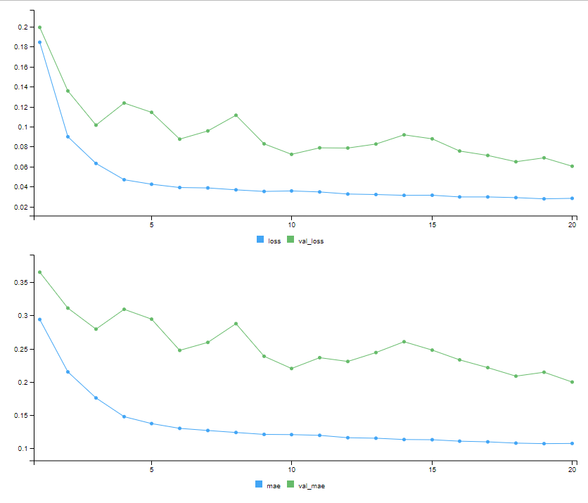

Figure 2. Stacked GRU
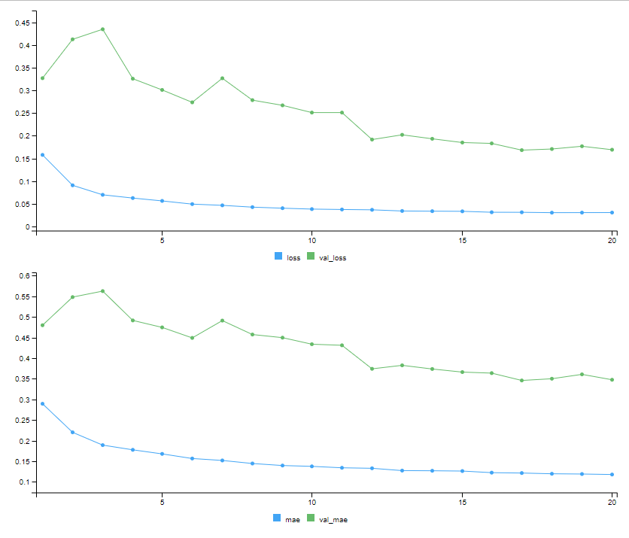

Figure 3. LSTM
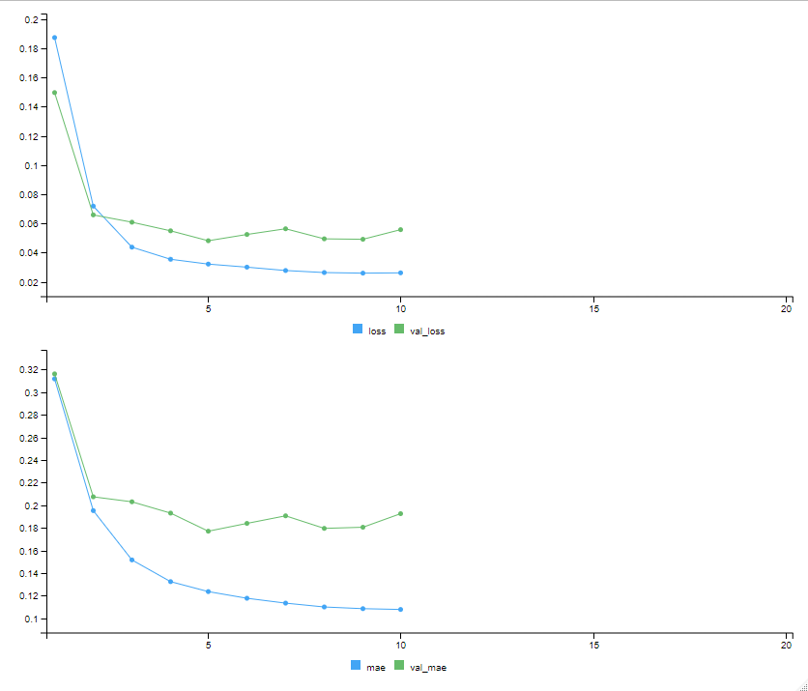

Figure 4. Conv1D + GRU
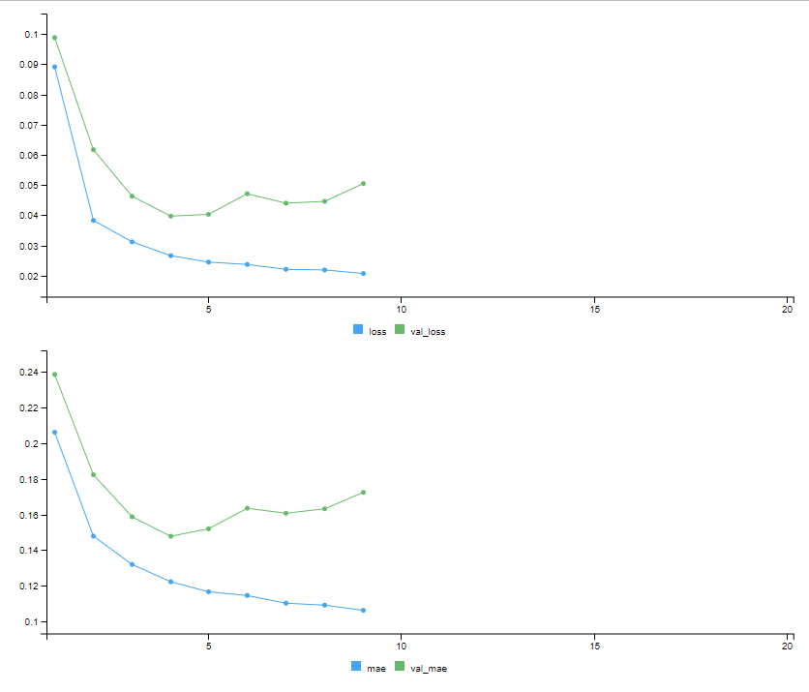
Among all models, the Conv1D + GRU model achieved the lowest validation MAE (0.1478) and was selected as the final model. When evaluated on the test set, it also produced the lowest test MAE (0.1507), indicating that it generalized well to unseen data. To better interpret these results, the test MAE was converted back to the original temperature scale. The temp was temp 1.32183. When temp_sd X test_mae = Final MAE which was 1.32183 X 0.1507215 ≈ 0.199. So the Final MAE was 0.2 degree. This corresponds to an average error of about 0.2°C, meaning the model’s predictions are typically within 0.2 degrees Celsius of the actual temperature.
Discussion
Several observations can be drawn from these results. First, the Conv1D + GRU model clearly performed the best, which suggests that capturing short-term patterns with a convolutional layer before applying a recurrent layer can improve forecasting accuracy.
Second, the LSTM model performed better than the baseline GRU, but the difference was not very large. While LSTM is designed to capture longer-term dependencies, it does not always lead to significantly better results in every situation.
Another interesting finding is that increasing model complexity does not automatically improve performance. The stacked GRU model, despite having more layers, performed worse than the simpler models. This likely reflects overfitting or unnecessary complexity for this particular dataset.
Finally, the very low prediction error suggests that the model benefits not only from its architecture but also from the relatively smooth and predictable nature of temperature data over short time periods.
Conclusion
In assignment 3, four RNN-based models were applied to a weather time-series forecasting problem. Among the models tested, the Conv1D + GRU model performed the best, achieving the lowest validation and test MAE. When converted back to the original temperature scale, the model achieved an average prediction error of approximately 0.2°C, indicating a high level of accuracy. Overall, the results show that model design is more important than simply increasing complexity, and that combining convolutional and recurrent layers can lead to better performance in time-series forecasting.

